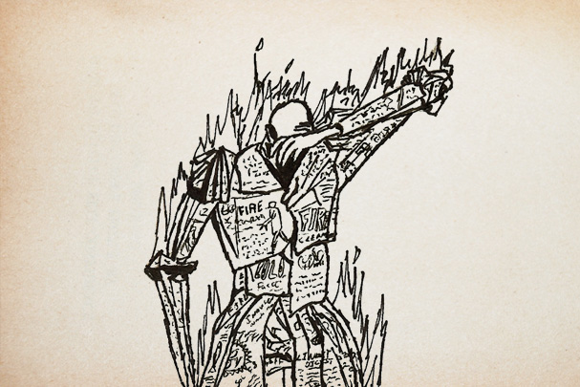
To What Extent Do The Themes of Fahrenheit 451
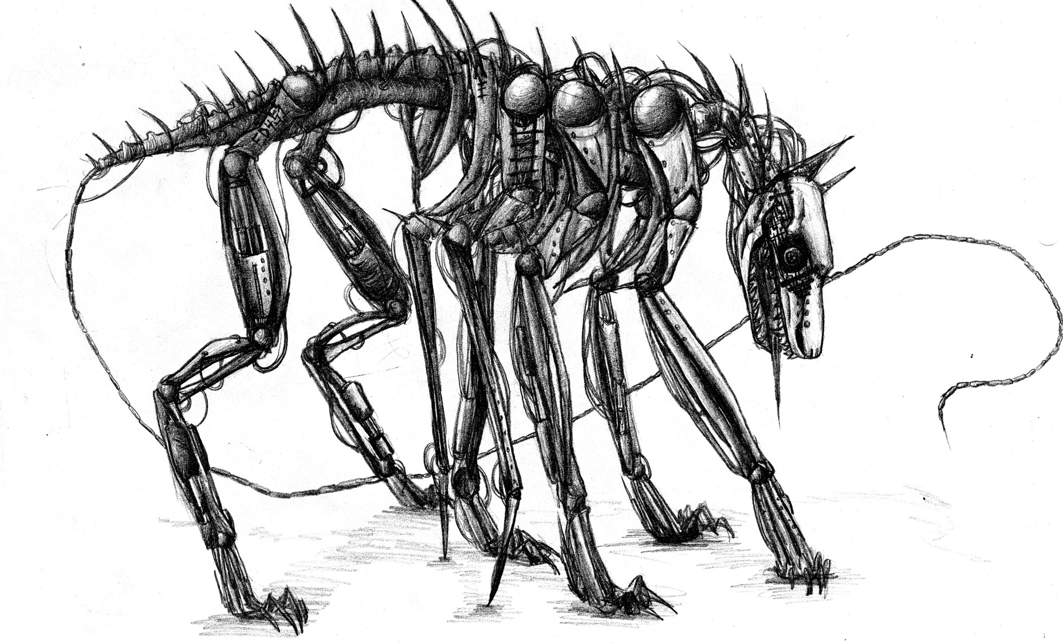
Reflect Current Events?
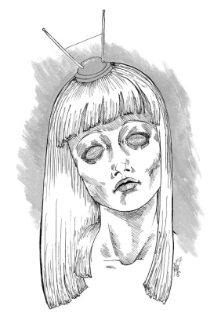

Discover
Literary Theory
Plot, Foreshadowing, & Suspense
Setting
Characterization
Irony (Situational)
Allusion
Character Arc & Conflict
Fahrenheit 451

Compose
WordPress Blog
(www.wordpress.com)
Creative Reader-Response
Research Essay
Annotated Bibliography

Share
Socratic Seminar
Ted Talk Presentation

Evaluated Anchor Skills
- I can determine central ideas or themes of a text and analyze their development; I can summarize the key supporting details and ideas (R.2).
- I can analyze how and why individuals, events, or ideas develop and interact over the course of a text (R.3).
- I can interpret words and phrases as they are used in a text, including determining technical, connotative, and figurative meanings, and analyze how specific word choices shape meaning or tone (R.4).
- I can present information, findings, and supporting evidence such that listeners can follow the line of reasoning and the organization, development, and style are appropriate to task, purpose, and audience (SL.4).
- I can make strategic use of digital media and visual displays of data to express information and enhance understanding of presentations (SL.5).
- I can conduct short as well as more sustained research projects based on focused questions, demonstrating understanding of the subject under investigation (W.7).
- I can gather relevant information from multiple print and digital sources, assess the credibility and accuracy of each source, and integrate the information while avoiding plagiarism (W.8).
- I can draw evidence from literary or informational texts to support analysis, reflection, and research (W.9).
Literary Theory
Biological Literature

Literary theory is the study of the methods to analyze literature. The theory of Biological Literature suggests that a text is a product of its author and the time in which it is written; an author, then, integrates his or her beliefs and experiences, including major historical events, into the text.

Assignment
To understand Biological Literature as it applies to Fahrenheit 451, select a significant national or global event of the 1950s that occurred during the writing of Fahrenheit 451 below and collect three pieces of evidence relating to the selected event; you must include an authentic photograph and quote in your evidence collection. Provide a brief explanation of each piece of evidence and evaluate what each piece suggests about Fahrenheit 451 using supporting details. You will present your assignment to the class.

National & Global Events of the 1950s

McCarthyism in America
- Un-American Activities Committee
- Hollywood Ten
- American Communist Party
- Joseph McCarthy
- Edward R. Murrow

Miscellaneous
- Science Fiction
- Utopia
- Dystopia
The Atomic Age
- Atomic Bomb (Hiroshima & Nagasaki)
- Joseph Stalin (Totalitarianism)
- USSR
- Cold War
- Iron Curtain
- Civil Defense
- Air Raid
- Bomb Shelter

Plot

Plot is the events that compose a story, particularly as they relate to one another in a pattern, in a sequence, through cause and effect, through the reader’s perspective of the story, or simply by coincidence. The events, or elements, of plot are explained in the graphic organizer below.
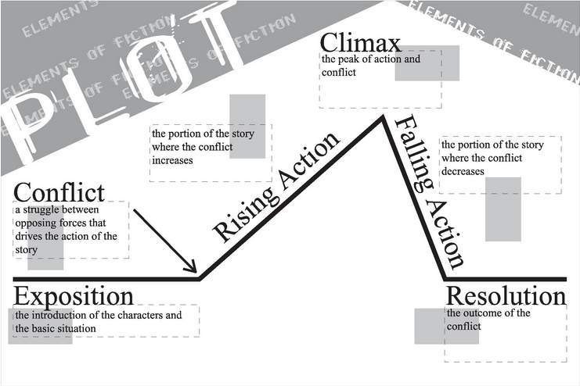
Foreshadowing & Suspense

Foreshadowing is a plot device in which the author hints or warns of what is to come in the story. Suspense, another plot device, is uncertainty in the story that creates anticipation or worry in the reader. Often, foreshadowing and suspense are combined to engage a reader.

Assignment
Identify an example of foreshadowing or suspense in Fahrenheit 451 and evaluate its effects in engaging the reader using cited textual evidence, including at least one quote. What does the example of foreshadowing hint or warn about? What does the example of suspense create anticipation or worry about? Your evaluation must be between 100-250 words.

Post the completed assignment on your WordPress blog to receive an evaluation.

Setting

Setting is the time period, location, and duration of an event in a story. While the setting exists throughout a story, it is often emphasized in the exposition to immediately establish the environment.

Assignment
You are visiting the world of Fahrenheit 451 and sending a postcard to a family member or friend describing your visit. Design a picture that represents a setting of Fahrenheit 451 and write a description of your experience there using cited textual evidence, including at least one quote.

Characterization

Characterization is the process by which the writer reveals the personality of a character directly or indirectly. Direct characterization tells the personality of the character while indirect characterization shows the personality of the character.

For example, direct characterization of a sad girl will tell the reader “the girl is sad” while indirect characterization will show the reader that “the girl’s cheeks are stained with tears and a faint whimper is heard beneath her breath.”

Assignment
Select a major character of Fahrenheit 451 and complete the indirect characterization chart below. You will perform an improvised skit with the class as your selected character.

Post the completed assignment on your WordPress blog to receive an evaluation.

Speech | What Does the Character Say?  How Does the Character Speak? | Explanation  “Quote” (Bradbury)
Thoughts | What is Revealed Through the Character’s Private Thoughts/Feelings? | Explanation  “Quote” (Bradbury)
Effect on Others Towards the Character | How Do Other Characters Feel or Behave in Reaction to the Character? | Explanation  “Quote” (Bradbury)
Actions | What Does the Character Do?  How Does the Character Behave? | Explanation  “Quote” (Bradbury)
Looks | What Does the Character Look Like?  How Does the Character Dress? | Explanation  “Quote” (Bradbury)

Irony

Irony in a story is generally defined as a literary device where something is the opposite of what it is expected to be. Situational irony refers specifically to situations or events where the outcome is contradictory or the opposite of what is expected.

Examples of situational irony include a police station getting robbed, a pilot having a fear of heights, a post on Facebook complaining about social media, an anti-technology website, and a teacher failing a test.

Assignment
Identify an example of situational irony in Fahrenheit 451 and evaluate its purpose (what is it communicating?) using cited textual evidence, including at least one quote. Your evaluation must be between 100-250 words.

Post the completed assignment on your WordPress blog to receive an evaluation.

Allusion

An allusion is a literary device in which the author refers to a historical event, famous individual, landmark, or well-known work of art.

Assignment
Select an allusion in Fahrenheit 451 below, research it, and present your research to the class.

Allusions in Fahrenheit 451

- Benjamin Franklin (34)
- Dante (50)
- Jonathan Swift (50)
- Marcus Aurelius (50)
- Hercules (83)
- Antaeus (83)
- Milton (87)
- Sophocles (87)
- Aeschylus (89)
- Vesuvius (93)
- Cheshire Cat (93)
- “Dover Beach” (99)
- Sir Philip Sidney (106)
- Alexander Pope (106)
- Icarus (“Fly near the sun…”) (113)
- Cassius from Julius Caesar (119)
- Keystone Cops (138)
- Plato (151)
- Plato’s Republic (151)
- Charles Darwin (151)
- Schoppenheimer (151)
- Albert Einstein (151)
- Mahatma Gandhi (151)
- Thomas Love Peacock (151)
- Thomas Jefferson (151)
- Confucius (151)
- Buddha (151)
- Swift’s Gulliver’s Travels (151)
- Albert Schweitzer (151)
- Lord Byron (152)
- Thomas Paine (152)
- Machiavelli (152)
- Henry David Thoreau (153)
- Bertrand Russell (153)
- Thoreau’s Walden (153)
- “Ecclesiastes” from The Bible (160)
- “Revelations” from The Bible (160)
- Tree of Life (165)
- Conan Doyle’s Baskerville Feast (173)

Questions to Consider (When Appropriate)
When was the work of art publicly revealed? When was the individual born? What was happening historically during the event?
Why is the individual, event, or work of art important?
What theme(s) does the work of art emphasize? What was the individual best known for?
Character Arc & Conflict

A character arc is the development of a major character throughout the plot; as the plot progresses, so does the character’s thoughts and actions. Often, the character arc (and plot) is driven by conflict, or a struggle between two opposing forces. Internal conflict is a struggle between a character and himself or herself while external conflict is a struggle between a character and something outside of him or her, like another character or nature/society. In a typical character arc, a character begins by struggling with his or her conflict, overcomes it during the climax of the plot, and changes in the process, ending the character arc as a significantly different character.

Characters having a character arc are often labeled as round characters, for they are well-rounded and multi-dimensional; characters without a character arc are often labeled as flat characters, for they are thin and one-dimensional.

Assignment
Select a round character from Fahrenheit 451 and evaluate his or her character arc throughout the story by describing the character’s beginning thoughts and actions, significant conflict(s), and ending changes in thoughts and actions after the climax of the plot using cited textual evidence, including at least one quote. Your evaluation must be between 150-300 words.

Post the completed assignment on your WordPress blog to receive an evaluation.

Reader-Response Discussion Questions & Quotes

A common reading comprehension technique is reader-response, a process by which a reader responds to what he or she reads through inquiry (asking and answering questions) and analysis.

Assignment
Read “The Sieve and the Sand” and “Burning Bright” sections of Fahrenheit 451, select two questions from each section, and answer them using textual evidence; to expedite the completion of this assignment, citations and quotes are not required but still encouraged.

“The Sieve and the Sand” Discussion Questions

1. In thinking about Clarisse’s friendship and her death, Montag goes “…trembling along the hall to the kitchen” (68). Why has his brief interaction with her made such an impact on him?

2. How does Montag answer Mildred when she asks why she should read? What does their exchange indicate about the differences between them?

3. Although Montag’s country has won “two atomic wars since 2022” (69), the threat of another war grows stronger. What reason does Montag give for the country being hated so much? How might books help Montag’s countrymen relate to peoples of other countries?

4. How does the sieve and the sand analogy apply to Montag?

5. When Montag visits Faber, Faber calls himself a coward. Why? In what way has he acted cowardly?

6. Faber tells Montag; “It’s not books you need, it’s some of the things that once were in books” (78). What is it that Montag needs and is searching for?

7. According to Faber, what three things are necessary to the pursuit of happiness? To what degree has Montag gained each of these three factors in his life at this point of the novel?

8. Why is Faber so discouraged about changing society for the better even if a war wipes out the current culture in their country?

9. Why does Montag not heed Faber’s warnings and instead confronts the women in his house with a reading of “Dover Beach”?

10. When Montag returns to the firehouse for work, he is divided. What are the divisions within himself that he experiences?

11. The Captain recounts his dream in which he defeats Montag’s argument for the importance of books. Choose one of the Captain’s quotes that directly argues against the power of books and explain what the quote means.

12. How does Montag feel about himself as he rides the fire truck with the other men to burn more books?

“The Sieve and the Sand” Quotes

“Maybe the books can get us half out of the cave. They just might stop us from making the same damn insane mistakes!” (70).

“The train radio vomited upon Montag, in retaliation, a great tonload of music made of tin, copper, silver, chromium, and brass. The people were pounded into submission; they did not run, there was no place to run…” (75).

“I often wonder if God recognizes His own son the way we’ve dressed him up, or is it dressed him down? He’s a regular peppermint stick now, all sugar-crystal and saccharine when he isn’t making veiled references to certain commercial products that every worshiper absolutely needs” (77-78).

“I’m one of the innocents who could have spoken up and out when no one would listen to the ‘guilty,’ but I did not speak and thus became guilty myself” (78).

“Books were only one type of receptacle where we stored a lot of things we were afraid we might forget. There is nothing magical in them, at all. The magic is only in what books say, how they stitched the patches of the universe together in one garment for us” (79).

“The things you’re looking for, Montag, are in the world, but the only way the average chap will ever see ninety-nine percent of them is in a book. Don’t ask for guarantees. And don’t look to be saved in any one thing, person, machine, or library. Do your own bit of saving, and if you drown, at least die knowing you were headed for shore” (82).

“Those who don’t build must burn. It’s as old as history and juvenile delinquents” (85).

“If you hide your ignorance, no one will hit you and you’ll never learn” (100).

“Burning Bright” Discussion Questions

1. What do you think caused Mildred to bring about the destruction of her own house by reporting that her husband had hidden books?

2. Why does Beatty want Montag to wield the flamethrower to destroy his own house and why does Montag acquiesce?

3. Almost without knowing it, Montag’s hands switch off the safety on the flame thrower aimed at Beatty. What does this show about Montag’s state of awareness or consciousness?

4. Why do you think Beatty mockingly tells Montag to “pull the trigger” (113) on the flamethrower Montag has aimed at him?

5. Is Montag justified in killing Beatty? Why or why not?

6. Why do the teenagers in the car try to kill Montag as he crosses the avenue? How do their actions reflect what is happening in society?

7. What is fitting about Montag’s planting books in Fireman Black’s home?

8. What insight about himself does Montag gain as he reflects on his violent actions?

9. Even though war has been declared, the news media focuses on the Mechanical Hound’s tracking of Montag. What does this say about the function of the media in society?

10. If Montag were caught and dying, what single word or phrase do you think he could say to the TV cameras that would wake the people up to the enforced triviality of their lives?

11. What insight about time and the sun and his actions as a fireman does Montag get during his leisurely float on the river? What does Montag understand humans must do to counter the effects of the time-burning sun?

12. How is the campfire different from the burning fire with which Montag is familiar?

13. What is so remarkable to Montag about the voices around the campfire he hears as he hides in the trees?

14. How is Montag like the men he encounters gathered around the campfire?

15. What do Montag’s imaginings about Mildred’s fate when the bombs fall indicate about him?

16. What, according to Granger, makes humans different from the Phoenix? How will this help humankind finally?

17. Why do you think that the old men fall in behind Montag on their journey back to the city? Why has he become the leader?

18. What is the significance of the quote that Montag will save for noon when they reach the city?

“Burning Bright” Reader-Response Quotes

“It was pretty silly, quoting poetry around free and easy like that. It was the act of a silly damn snob. Give a man a few lines of verse and he thinks he’s the Lord of all Creation” (111).

“Faber’s would be the place where he might refuel his fast draining belief in his own ability to survive. He just wanted to know that there was a man like Faber in the world” (118).

“I could feel it for a long time, I was saving something up, I went around doing one thing and feeling another….It’s a wonder it didn’t show on me, like fat” (125).

“He could feel the Hound, like autumn, come cold and dry and swift….The Hound did not touch the world. It carried its silence with it, so you could feel the silence building up a pressure behind you all across town” (130).

“Here was the path to wherever he was going. Here was the single familiar thing, the magic charm he might need a little while, to touch, to feel beneath his feet, as he moved on into the bramble bushes and the lakes of smelling and feeling and touching, among the whispers and the blowing down of leaves” (138).

“The most important single thing we had to pound into ourselves is that we were not important….We’re nothing more than dust jackets for books, of no significance otherwise” (146).

“Everyone must leave something behind when he dies….A child or a book or a painting or a house or a wall built or a pair of shoes made. Or a garden planted. Something your hand touched some way so your soul has somewhere to go when you die, and when people look at that tree or that flower you planted, you’re there” (149-150).

“We’ll just start walking today and see the world and the way the world walks around and talks, the way it really looks….And while none of it will be me when it goes in, after a while it’ll all gather together inside and it’ll be me” (154).

Research Essay

Assignment
Read Fahrenheit 451 by Ray Bradbury, determine a theme of the novel, and analyze to what extent the theme reflects current events; if in a group, each group member must select a different current event. Your analysis must be written in an academic essay, synthesize at least three researched sources, include an annotated bibliography, and contain cited textual evidence from Fahrenheit 451, including at least one quote. Additionally, your academic essay must be typed or pen-written, MLA-formatted, and between 350-500 words.

Attach your research note cards to the academic essay to receive an evaluation.

Research Note Cards
(Five Per Source)
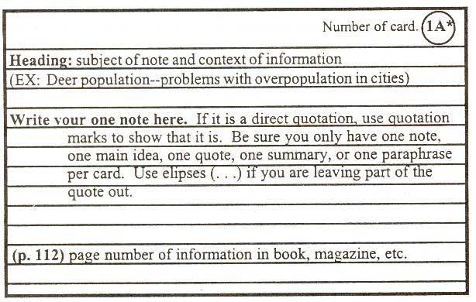

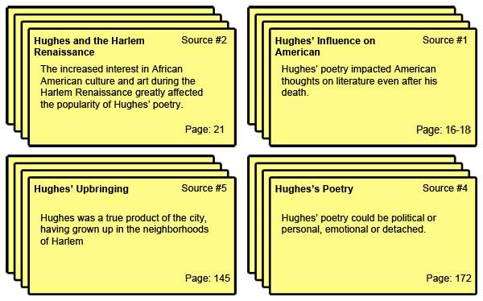

Research-Based Argument Academic Essay Organizer
Introduction Paragraph
Attention-Getter/Hook & Information Relating to Thesis:

Thesis Statement: The theme of oppression in Fahrenheit 451 reflects Russia under the rule of despotic Josef Stalin.
Subtopic 1: Stalin adopted a policy of totalitarianism that allowed him to control every aspect of society.
Subtopic 2: Stalin murdered and exiled anyone who opposed him, even if they were popular political opponents.
Subtopic 3:

CSET Supporting Paragraph –Subtopic 1
Subtopic 1 (Claim): Stalin employed totalitarian tactics to subdue the Russian people.
Detail (Set-Up/Evidence): Stalin forced all media, including television stations, newspapers, radio broadcasts, and even church services to promote him and his regime as a perfect savior of the Russian people. Anyone who declined to promote or follow Stalin was murdered by his Secret Police (Brooks 18-21). With everyone holding the same beliefs, Stalin thought, society can function most effectively.
Analysis (Tie-In): Totalitarianism and the pursuit of sameness also infiltrates the society in Fahrenheit 451, as the government controls information and, like Stalin, punishes those who refuse to cooperate with their demands and ideals. Beatty states to Montag, “We must all be alike. Not everyone born free and equal, as the Constitution says, but everyone made equal” (Bradbury 57), which shows the need to control…

CSET Supporting Paragraph –Subtopic 2
Subtopic 2 (Claim):
Detail (Set-Up/Evidence):
Analysis (Tie-In):

CSET Supporting Paragraph –Subtopic 3
Subtopic 3 (Claim):
Detail (Set-Up/Evidence):
Analysis (Tie-In):

Conclusion Paragraph
Restated Thesis Statement & Subtopics:

Concluding Sentence Engaging & Satisfying the Reader:

Category | 4 – Expert Mastery | 3 – Proficient Mastery | 2 – Insufficient Mastery | 1 – No Mastery
Focus  The text focuses on a topic to inform a reader with ideas, concepts, information, etc | The text clearly focuses on a compelling topic that informs the reader with ideas, concepts, information, etc. | The text focuses on an interesting topic that informs the reader with ideas, concepts, information, etc. | The text has an unclear topic with some ideas, concepts, information, etc. | The text has an unidentifiable topic with minimal ideas, concepts, information, etc.
Development  The text presents relevant facts, definitions, concrete details, quotations, examples, and a conclusion | The text provides significant facts, definitions, concrete details, and quotations that fully develop and explain the topic. The conclusion provides insight to the implications, explains the significance of the topic, and projects to the future, etc. | The text provides effective facts, definitions, concrete details, quotations, and examples that sufficiently develop and explain the topic. The conclusion provides the implications, significance of and future relevance of the topic, etc. | The text provides facts, definitions, details, quotations, and examples that attempt to develop and explain the topic. The conclusion merely restates the development. | The text contains limited facts and examples related to the topic. The writing may fail to offer a conclusion.
Audience  The author anticipates the audience’s background knowledge of the topic | The text consistently addresses the audience’s knowledge level and concerns about the topic. The text addresses the specific needs of the audience. | The text anticipates the audience’s knowledge level and concerns about the topic. The text addresses the specific needs of the audience. | The text illustrates an inconsistent awareness of the audience’s knowledge level and needs. | The text lacks an awareness of the audience’s knowledge level and needs.
Cohesion  The text uses appropriate and varied transitions to link the major sections of the text, creates cohesion, and clarifies the relationships among complex ideas and concepts | The text strategically uses words, phrases, and clauses to link the major sections of text. The text explains the relationships between the topic and the examples and/or facts. | The text skillfully uses words, phrases, and clauses to link the major sections of the text. The text identifies the relationship between the topic and the examples and/or facts. | The text contains limited words, phrases, and clauses to link the major sections of the text. The text attempts to connect the topic and the examples and/or facts. | The text contains few, if any, words, phrases, and clauses to link the major sections of the text. The text does not connect the topic and the examples and/or facts.
Language & Style  The text presents a formal, objective tone and uses precise language and topic-specific vocabulary to manage the complexity of the topic | The text presents an engaging, formal, and objective tone and uses sophisticated language and topic-specific vocabulary to manage the complexity of the topic. | The text presents an appropriate formal, objective tone and uses relevant language and topic-specific vocabulary to manage the complexity of the topic. | The text illustrates a limited awareness of formal tone and awareness of topic-specific vocabulary. | The text illustrates a limited or inconsistent tone and awareness of topic-specific vocabulary.

TED Talk

A TED Talk is a short presentation of powerful ideas that began over twenty years ago at a convention on technology, entertainment, and design (TED).

Assignment
Design a TED Talk presentation on the extent to which Fahrenheit 451 reflects current events using researched sources and other information from your research essay; in a group, the entire group must present one TED Talk. Your TED Talk must include a visual and be within 3-5 minutes.

TED Talk Notes

________________________________________________
(Title of TED Talk)

I Like… | I Dislike or Would Improve…

________________________________________________
(Title of TED Talk)

I Like… | I Dislike or Would Improve…

________________________________________________
(Title of TED Talk)

I Like… | I Dislike or Would Improve…

